September 24, 2025

To all Eastern Star Sisters and Brothers,

On behalf of our Most Worthy Grand Matron, Sister Billie Bradfield, and Most Worthy

Grand Patron, Brother Michael E. Berry, I am authorized and honored to share this important message with you.

As many of you may have heard, a Celebration to honor America’s 250th Birthday will be held at the International Headquarters, the Perry Belmont House, on July 3, 2026, in our nation’s capital. This is an exciting time to be in Washington, D.C. to participate in such an historic event.

Along with this letter, I am sending a formal invitation to attend, along with the information about the Dupont Circle Hotel wherein rooms have been secured for your convenience.

Please spread the word and join us in celebrating our Nation’s 250th Birthday!

Fraternally,

Kathryn A. Newman

Kathryn A. Newman

Chairman of the Celebrations in DC Committee

P.G.M., Grand Secretary of Rhode Island

This letter is approved and endorsed by:

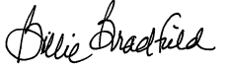 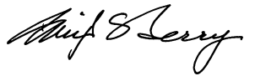

Billie Bradfield Michael E. Berry

Most Worthy Grand Matron Most Worthy Grand Patron

